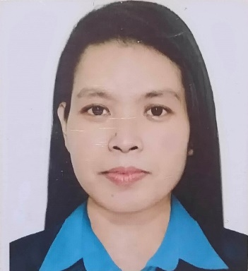

**MYLENE Q.LAZAC**

**15 J Zobel Street,Barangay Masagana Project 4,Quezon City.**

**Email:** [**mylenelazac98@gmail.com**](mailto:mylenelazac98@gmail.com)

**Contact: 0969-421-4520**

**PERSONAL INFORMATION**

**BIRTH PLACE :** Balamban,Cebu

**BIRTH DATE :** February 12,1984

**AGE :** 39 years old

**CIVIL STATUS :** Single

**GENDER :** Female **HEIGHT :** 152cm

**WEIGHT :** 55kg

**RELIGION :** Catholic

**WORK EXPERIENCE**

**HOUSEHOLD SERVICE WORKER**

**Riyadh,Kingdom of Saudi Arabia**

**Dec 20,2020 - Jan 2,2023**

* Cleaned the living room, dining room, bedrooms, kitchen, bathrooms and replenished toiletries
* Washed kitchen utensils, drained and placed them inside the dish organizer or cabinet
* Changed bed linens
* Prepared food and set up the dining table
* Carried the Wet and Dry goods to the storage-room and arranged properly
* Washed clothes, ironed, folded clean clothes then placed them inside their respective closet orderly
* Segregated of non-biodegradable and biodegradable waste materials before discarding

**CEBU SHINSHEI INC / PRODUCTION WORKER**

**Lapu-lapu City,Cebu**

**Nov 2018 - Dec 2019**

**Winding Department (Camera)**

* Handled Machine - Winding Machine
* Performed appearance check every winded lens holder
* Placed the winded holder into the pallet properly
* Filled in the Monitoring chart every lot completed
* Replaced coil wire if needed
* Filled out the Monitoring slip every end of the shift

**CEBU MITSUMI INC / PRODUCTION WORKER**

**Sabang Danao City,Cebu**

**Nov 2004 - Dec 2006**

**FDD Department (floppy disk drive)**

* Handled Machine - IF/2 Check
* Checked the eject spring inside of Floppy disk drive (FDD) unit by using blanked diskette back and forth
* Inserted the FDD unit into the jig properly.
* Detached the FDD unit from the jig carefully
* Performed appearance check of FDD unit
* Attached front panel precisely and checked any scratched or discoloration
* Handed the FDD unit to the next Process/Operator

**SKILLS**

* Ability to stand and work for extended period of time
* Ability to organize time and workload
* Multitasking
* Can fix minimal machine glitch
* Thoroughly followed instructions

**EDUCATION**

**TERTIARY** PAMANTASAN NG LUNGSOD NG MAYNILA 2002 - 2003

BS INFORMATION TECHNOLOGY

Undergraduate

**SECONDARY** DONA TEODORA ALONZO HIGH SCHOOL 1997 - 2001

Sta Cruz,Manila

**PRIMARY** BALAMBAN CENTRAL ELEM.SCHOOL 1991 - 1997

Balamban,Cebu